**Príklad 1:** Zapíš polohu bodov A, B, C, D v rovine:

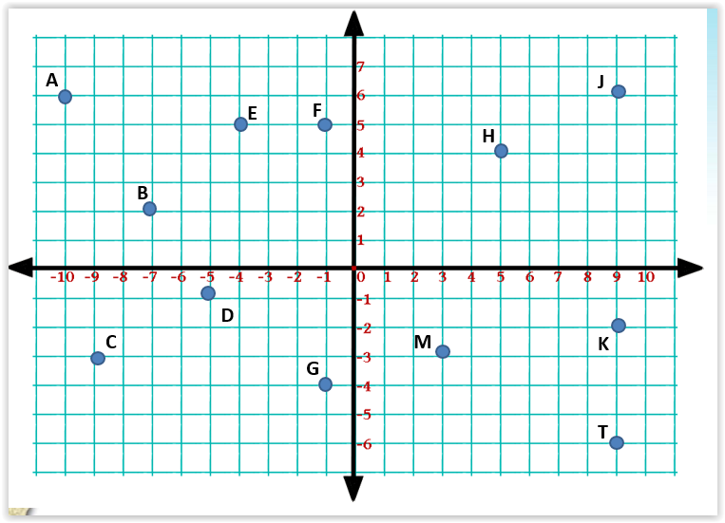

**Príklad 2:** Vyznač v karteziánskej sústave súradníc tieto body:

1. *A = [3,2], B = [8,4], C = [1,7], D = [0,6]*
2. *K = [-3,2], L = [3,-1], M = [-1,1], N = [-2,-3]*
3. *E = [0,1], F = [4,-4], G = [-4,5], H = [-5,1]*
4. *X = [1,-3], Y = [-3,-2], U = [5,-4], V = [2,-6]*
5. *P = [2,-5], S = [2,-1], R = [0,6], T = [-5,0]*

